* 1. The experimental units are thin films of silicon dioxide and photoresist with the response variable being thickness of film (measured in angstroms infrared interference). There are two factors in the experiment (pressure and temperature) each having 3 different levels (low, middle and high).
  2. This is an experimental study as we assign treatments(pressure and temperature combinations) to our study subjects(metal films). Since we are assigning random treatments but not randomly selecting our populations, we can only make causal inferences and not population inferences. Since they are repeating the experiment 3 times, it should be a bit more reliable. However, three times is too little to get very reliable result and most experiments opt towards 10+ repeats. Assumptions we assume are that each interval between each level is equal and that we have Independent observations. We must assume that for each combination of treatments, the response variable must be normally distributed and for all treatment combinations, our response variable must have equal standard deviations
  3. 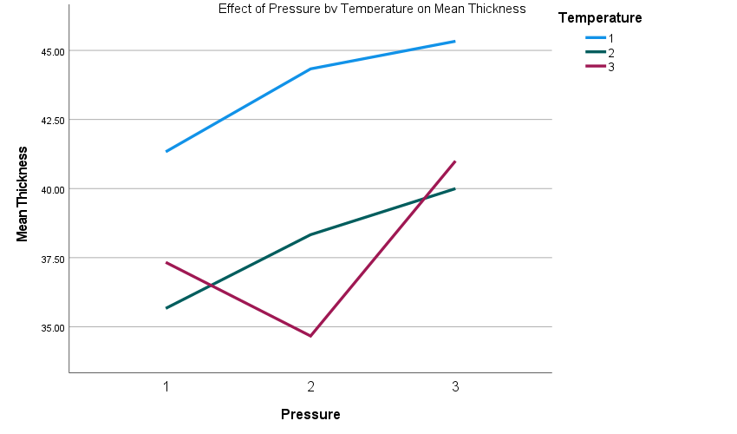The combination that produces the smallest thickness is a low pressure and medium temperature whereas the thickest resulting combination is the lowest temperature on highest pressure. From the graph, we can see that none of the lines are parallel to each other which indicates an interactive effect between temperature and pressure. If we look at the graph horizontally, we can see as we move from one pressure value to another we can see that as pressure increases thickness increases for all temperature values except level 3 in which it first decreases then increases whereas if we look vertically we can see that as temperature increases mean thickness decreases at pressure level 2 whereas at levels 1 and 3 as temperature increases, it initially decreases but that increases(still lower than level one) .

|  |  |  |  |  |
| --- | --- | --- | --- | --- |
| **Report** | | | | |
| Thickness | | | | |
| Temperature | Pressure | Mean | N | Std. Deviation |
| 1 | 1 | 41.3333 | 3 | 2.08167 |
| 2 | 44.3333 | 3 | 1.15470 |
| 3 | 45.3333 | 3 | 1.52753 |
| Total | 43.6667 | 9 | 2.29129 |
| 2 | 1 | 35.6667 | 3 | 1.52753 |
| 2 | 38.3333 | 3 | 1.15470 |
| 3 | 40.0000 | 3 | 2.00000 |
| Total | 38.0000 | 9 | 2.34521 |
| 3 | 1 | 37.3333 | 3 | .57735 |
| 2 | 34.6667 | 3 | 1.52753 |
| 3 | 41.0000 | 3 | 1.00000 |
| Total | 37.6667 | 9 | 2.91548 |
| Total | 1 | 38.1111 | 9 | 2.84800 |
| 2 | 39.1111 | 9 | 4.37163 |
| 3 | 42.1111 | 9 | 2.80377 |
| Total | 39.7778 | 27 | 3.71414 |

As pressure increase, mean thickness increases with the except of Temperature level 3 in which pressure decreases from pressure level 1 to 2 but from 2 to 3, mean thickness increases once again. As temperature increases, we have a weirder patter in the sense the at pressure level one, thickness decreases as we move from temperature 1 to 2 but as we move from temperature level 2 to 3, we see an increase again(level 3’s thickness is still smaller than level 1). Yet in pressure level 2, as temperature increase thickness decreases(consistent throughout all levels) When temperature is at 3 however, the same patter emerges from when the temperature level was one.

|  |  |  |
| --- | --- | --- |
| **Between-Subjects Factors** | | |
|  | | N |
| Temperature | 1 | 9 |
| 2 | 9 |
| 3 | 9 |
| Pressure | 1 | 9 |
| 2 | 9 |
| 3 | 9 |

|  |  |  |  |  |  |
| --- | --- | --- | --- | --- | --- |
| **Tests of Between-Subjects Effects** | | | | | |
| Dependent Variable: Thickness | | | | | |
| Source | Type III Sum of Squares | df | Mean Square | F | Sig. |
| Corrected Model | 320.000a | 8 | 40.000 | 18.621 | <.001 |
| Intercept | 42721.333 | 1 | 42721.333 | 19887.517 | <.001 |
| temp | 204.667 | 2 | 102.333 | 47.638 | <.001 |
| pressure | 78.000 | 2 | 39.000 | 18.155 | <.001 |
| temp * pressure | 37.333 | 4 | 9.333 | 4.345 | .012 |
| Error | 38.667 | 18 | 2.148 |  |  |
| Total | 43080.000 | 27 |  |  |  |
| Corrected Total | 358.667 | 26 |  |  |  |
| a. R Squared = .892 (Adjusted R Squared = .844) | | | | | |

H0: There is no main effect of pressure on mean thickness

Ha: There is a main effect of pressure on mean thickness.

F score:18.155

P-Value: <0.001

In conclusion at the 5% significance level, we reject the null hypothesis and claim that there is a main effect of pressure on mean thickness.

H0: There is no main effect of temperature on mean thickness

Ha: There is a main effect of temperature on mean thickness.

F score:47.638

P-Value: <0.001

In conclusion at the 5% significance level, we reject the null hypothesis and claim that there is a main effect of temperature on mean thickness.

H0: There is no interaction effect of temperature and pressure on mean thickness

Ha: There is a main effect of temperature and pressure on mean thickness.

F score: 4.345

P-Value: 0.012

In conclusion at the 5% significance level, we reject the null hypothesis and claim that there is a main effect of temperature and pressure on mean thickness.

|  |  |  |  |  |  |  |
| --- | --- | --- | --- | --- | --- | --- |
| **Multiple Comparisons** | | | | | | |
| Dependent Variable: Thickness | | | | | | |
| Tukey HSD | | | | | | |
| (I) Temperature | (J) Temperature | Mean Difference (I-J) | Std. Error | Sig. | 95% Confidence Interval | |
| Lower Bound | Upper Bound |
| 1 | 2 | 5.6667* | .69092 | <.001 | 3.9033 | 7.4300 |
| 3 | 6.0000* | .69092 | <.001 | 4.2367 | 7.7633 |
| 2 | 1 | -5.6667* | .69092 | <.001 | -7.4300 | -3.9033 |
| 3 | .3333 | .69092 | .880 | -1.4300 | 2.0967 |
| 3 | 1 | -6.0000* | .69092 | <.001 | -7.7633 | -4.2367 |
| 2 | -.3333 | .69092 | .880 | -2.0967 | 1.4300 |
| Based on observed means.  The error term is Mean Square(Error) = 2.148. | | | | | | |
| *. The mean difference is significant at the 0.05 level. | | | | | | |

|  |  |  |  |  |  |  |
| --- | --- | --- | --- | --- | --- | --- |
| **Multiple Comparisons** | | | | | | |
| Dependent Variable: Thickness | | | | | | |
| Tukey HSD | | | | | | |
| (I) Pressure | (J) Pressure | Mean Difference (I-J) | Std. Error | Sig. | 95% Confidence Interval | |
| Lower Bound | Upper Bound |
| 1 | 2 | -1.0000 | .69092 | .339 | -2.7633 | .7633 |
| 3 | -4.0000* | .69092 | <.001 | -5.7633 | -2.2367 |
| 2 | 1 | 1.0000 | .69092 | .339 | -.7633 | 2.7633 |
| 3 | -3.0000* | .69092 | .001 | -4.7633 | -1.2367 |
| 3 | 1 | 4.0000* | .69092 | <.001 | 2.2367 | 5.7633 |
| 2 | 3.0000* | .69092 | .001 | 1.2367 | 4.7633 |
| Based on observed means.  The error term is Mean Square(Error) = 2.148. | | | | | | |
| *. The mean difference is significant at the 0.05 level. | | | | | | |

Looking at the Tukey Post Hoc test for Temperature, we can see the only man difference in thickness which is not significant are when comparing temperature level 2 to temperature level 3. For the Tuckey Post Hoc Test for pressure, all of mean difference in thickness are significant with the exception of comparing pressure levels 2 and 3.



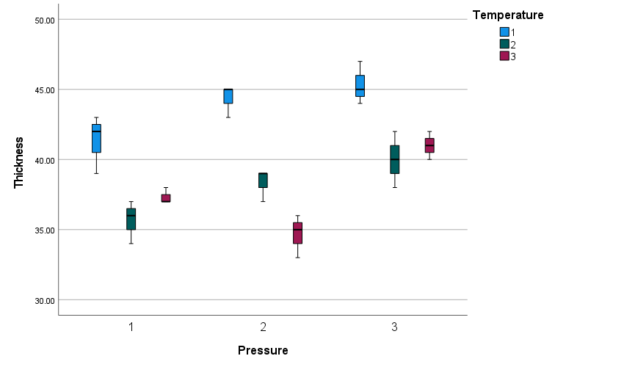

* 1. Looking at the box plot, we can see that for some of the combinations, we can see that equal variability is being violated. This is because the IQR for some of the combinations do not match at all. Such as Temperature Level 3 at pressure one does not match the IQR of the other temperature groups in the same grouping. For Pressure group 2&3, all the IQR differ. That means equal variability is being violated
  2. The normality assumption is being violated as none of the temperature groups in pressure groups one and two are symmetric. In pressure group 3. Groups 2 and 3 appear symmetric whereas group 1 is not symmetric at all as it is skewed.